Respiratory System - the organs used for breathing

Function: to oxygenate all parts of the body and expel carbon dioxide

Structure

- protected by ribcage
- Thoracic cavity (in the chest)
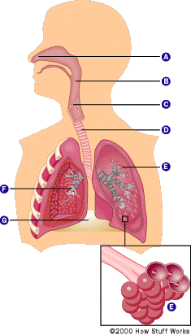

http://health.howstuffworks.com/lung1.htm

First - you inhale through your nasal cavity

your diaphragm and intercostals (those are the muscles between your ribs) contract and expand the chest cavity
the pressure in the chest cavity is lowered below the outside air pressure because of this expansion
Air then flows in through the airways (from high pressure to low pressure) and inflates the lungs

Next -you exhale through your nasal cavity

the diaphragm and intercostals relax and the chest cavity gets smaller
now the pressure outside is lower than inside your lungs
Air from the lungs (high pressure) then flows out of the airways to the outside air (low pressure)

Circulatory System - an organ system that passes blood to and from cells in the body

Function: to help fight diseases, stabilize body temperature and pH and to maintain homeostasis. “blood distribution network”

Structure:

The Heart -

Chambers and Valves and Veins

The heart is divided into four chambers:

right atrium (RA)
right ventricle (RV)
left atrium (LA)
left ventricle (LV)

Four Valves:

Tricuspid valve - at the exit of the right atrium.
Pulmonary valve - at the exit of the right ventricle.
Mitral valve - at the exit of the left atrium.
Aortic valve - at the exit of the left ventricle.

Veins:

superior vena cava (SVC) - upper half of body
inferior vena cava (IVC) - lower half of body
Pulmonary - lungs

One big Artery:

Pulmonary artery
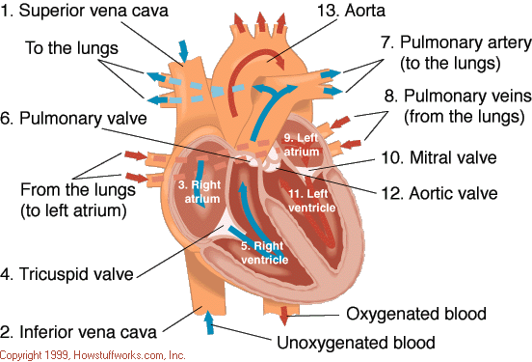

Blood Flow -
to the superior and inferior vena cava,
then to the right atrium
through the tricuspid valve
to the right ventricle
through the pulmonic valve
to the pulmonary artery
to the lungs
The blood picks up oxygen in the lungs, and then flows from the lungs:
to the pulmonary veins
to the left atrium
through the mitral valve
to the left ventricle
through the aortic valve
to the aorta
to the body

Why is this happening?

All parts of the body need oxygen to function, and our blood brings oxygen from the lungs to all the other parts of our body - thus it circulates blood and oxygen.

So - 2 loops are made
1. Loop 1 - right side of the heart pumps blood to the lungs first to pick up oxygen
2. Loop 2 - blood then returns to the left side of the heart where it is returned to the body full of oxygen

